KEYNOTES 2021

DR CAROLINE EDWARDS
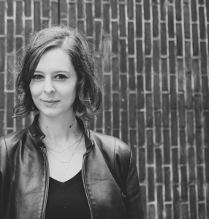
‘Hypnotic Inhumanism: The Welcome Descent into Decaying Worlds‘
This talk will explore a central tension at play within narratives of survival set amidst collapsing ecological worlds. In stories, films and artworks that anticipate the near and distant futures of climate crisis, can we be persuaded to side with the monstrous plants, moving rock formations, growing deserts, and rising seas that threaten our survival as a species? At what point does our sympathy for the animals, plants, insect life and ecological systems we are destroying become self-abnegation? Recent theoretical contributions to the environmental (post)humanities help us recognise our embeddedness within these systems but often avoid the more thorny issue of antihumanism, or inhumanism, revealed in speculative narratives of climate disaster. From ambivalent visions of antihuman becoming in J. G. Ballard’s 1960s ecocatastrophe fictions to Jeff VanderMeer’s unsettling “Southern Reach” trilogy; from N. K. Jemisin’s posthumanist assemblages in the lithic protagonists of the “Broken Earth” trilogy and their molten underworld of sub-crustal Earth to the agentive nonhumans in contemporary mycological fictions such as Tade Thompson’s “Rosewater” trilogy; and the watery intersubjectivity of gestational flood fictions by Megan Hunter and Abi Curtis that connect their protagonists with larger oceanic and estuarine bodies of water; to the unambiguously posthuman cinematic point of view in Nikolaus Geyrhalter’s post-apocalyptic Homo Sapiens; this talk will reflect upon these surprisingly optimistic ecocatastrophic visions which imagine how nature will endure, despite humanity’s ravages to the environment.
Dr Caroline Edwards is Senior Lecturer in Modern & Contemporary Literature in the Department of English & Humanities at Birkbeck, University of London, where she is actively involved with Birkbeck’s Centre for Contemporary Literature. Her research focuses on the utopian imagination in contemporary literature, science fiction, apocalyptic narratives, and Western Marxism. She is author of Utopia and the Contemporary British Novel (Cambridge University Press, 2019), which examines temporal experience and utopian anticipation in contemporary texts by British writers including Hari Kunzru, Maggie Gee, David Mitchell, Ali Smith, Jim Crace, Marina Warner, Sam Taylor, Joanna Kavenna, Grace McCleen, Jon McGregor, Patrick Ness and Claire Fuller.
Her work on contemporary writers has also led to two co-edited books: China Miéville: Critical Essays, co-edited with Tony Venezia (Gylphi, 2015) and Maggie Gee: Critical Essays, co-edited with Sarah Dillon (Gylphi, 2015). Caroline is currently working on her second monograph, Arcadian Revenge: Utopia, Apocalypse and Science Fiction in the Era of Ecocatastrophe, which considers how fictions of extreme environments (such as Mars, Antarctica, the deep sea, and the centre of the Earth) have allowed writers to imagine creative responses to real and perceived disasters about climate change, from the late 19th century to the present day.
PROFESSOR ALEX GOODY
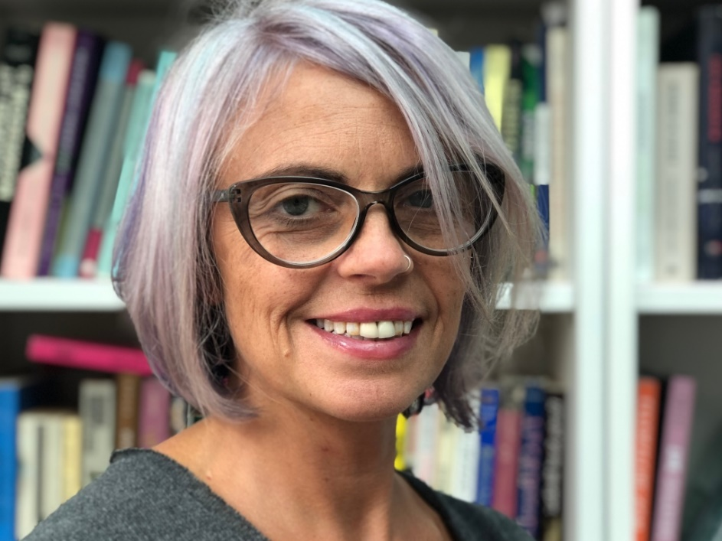
‘Surviving Slavery? Motherhood, Matriliny and Afrofuturism‘
In Beloved the murdered daughter of the escaped slave Sethe haunts her family and her home, returning in the flesh as a strange young woman who simultaneously manifests the impossibility of Sethe’s infanticidal act, the imposed separation from the slave mother and the communal lost memory of the middle passage. Beloved works in the irresolvable place that also generates Afrofuturism, what Mark Dery termed the ‘troubling antimony’ of how a ‘community whose past has been deliberately rubbed out, and whose energies have subsequently been consumed by searches for a legible trace of its history can imagine possible futures’ (Mark Dery, ‘Black to the Future’). This talk focuses on those ‘possible futures’ as imagined for black mothers and their kin. Taking as a starting point Morrison’s proto-afrofuturist recuperation of the violent losses of enslaved black Americans in Beloved, I explore Octavia E. Butler’s Kindred and Wild Seed and the HBO shows Westworld and Lovecraft Country to examine their re-articulations of the experience of black mothering. Revisiting re-imagined pasts to trouble and confront the inexorable history of African American enslavement and its ongoing legacies in a racist USA, these texts use fantastic devices (embodied haunting, immortal beings, time travel, the multiverse, space exploration, conscious AI robots) to offer narrative accounts of insurgent mothering and matriliny. Their different trajectories coalesce, I argue, in prospective visions that empower and redeem black mothers from racialised stereotypes and from the violent appropriations of slavery. Beloved is ‘not a story to pass on’; it articulates the impossible and unthinkable, the irrecuperable loss of matriliny and family. But, as I argue in this talk, it might be possible to find, in subsequent afrofuturisms, stories where black women define and claim their own relationships to embodiment, motherhood and kin, rewriting the enslaved past to survive and galvanise different futures.
Prof Alex Goody (BA., York; MA and Ph.D, Leeds) is a Professor of Twentieth-Century Literature and Culture at Oxford Brookes University. Her areas of research include modernist studies, technology and literature, and American literature and culture.
She has published books and articles on Mina Loy, Djuna Barnes, Gertrude Stein, American Modernism, New York Dada, technology and literature, jewish writing, contemporary poetry, modernist drama, and radio. Publications include: Technology, Literature and Culture (Polity Press, 2011) and Modernist Articulations: A Cultural Study of Djuna Barnes, Mina Loy and Gertrude Stein (Palgrave, 2007). Prof Goody’s current research projects include Of Women and Other Animals: Twentieth-century Women’s Poetry and the Non-Human Turn and an edited collection on Black Mirror.

